Lab mid exam:

Roll no:213064

Name:Khansa

Date :10/4/23

Question 1.

Write the XML code for following layout of an android activity.

Ans :

Here the xml code been starting as an Activity_main_xml.

While the project name is layout.

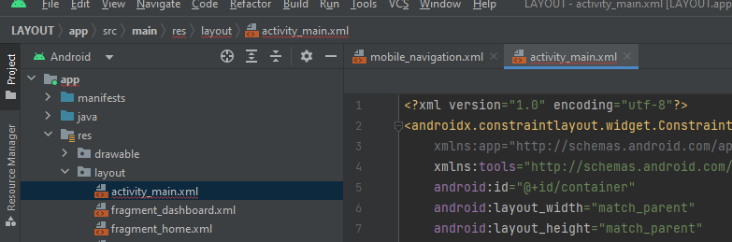

Before the design has been starting :

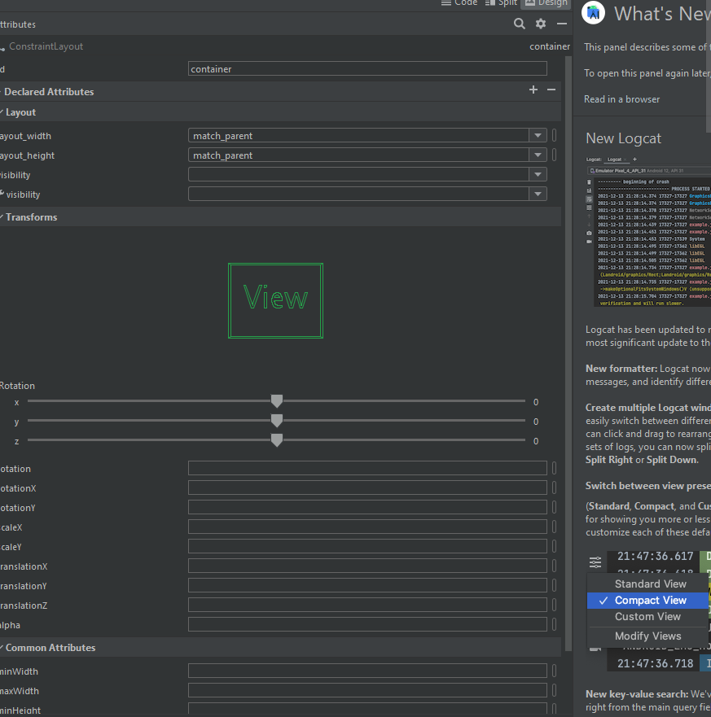

Question no 2:

Write code to implement intent to create an android app for a restaurant that allows customers to view the menu, select items they want to order, and place their order for pickup or delivery.

Ans:

Step1:

Create a new project .

Step2:

Add the following code to res/layout/activity_main.xml. (First Activity layout).

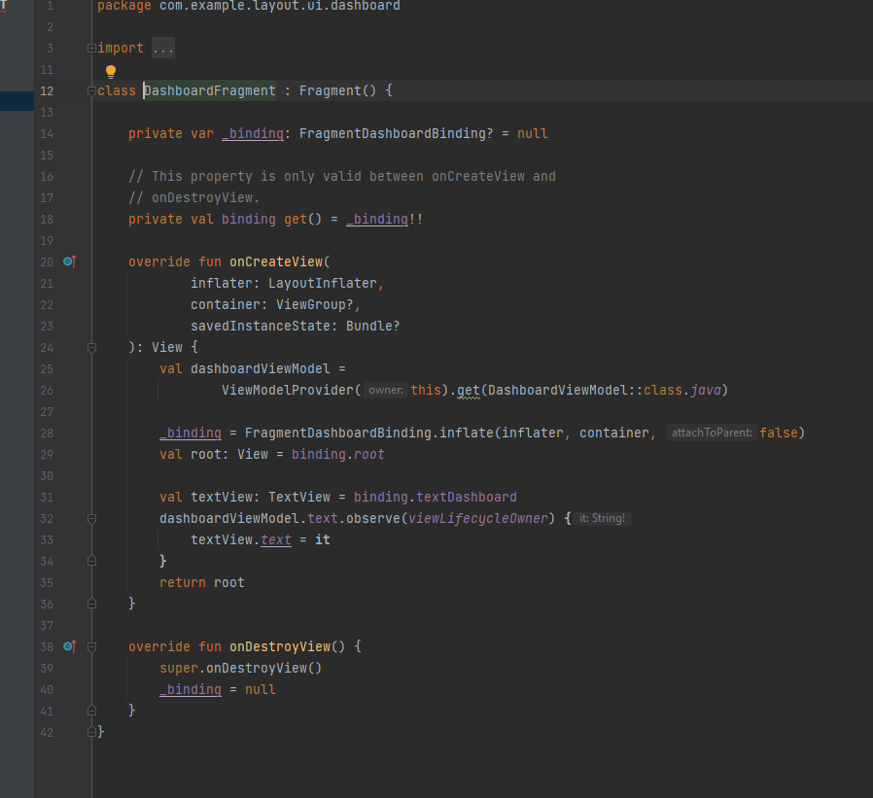

Step3:

Create a new layout in res/layout/ folder and add the following code to res/layout/activity_main.xml. (Second Activity layout )



Step4:

Add the following code to src/MainActivity.java (First activity)



Step5:

Create a new activity and add the following code to src/SecondActivity.java (Second Activity)



Step5:

Add the following code to AndroidManifest.xml.



Output:

